Nurse Task Prioritization Technical Response

Here’s a flow diagram for the task completion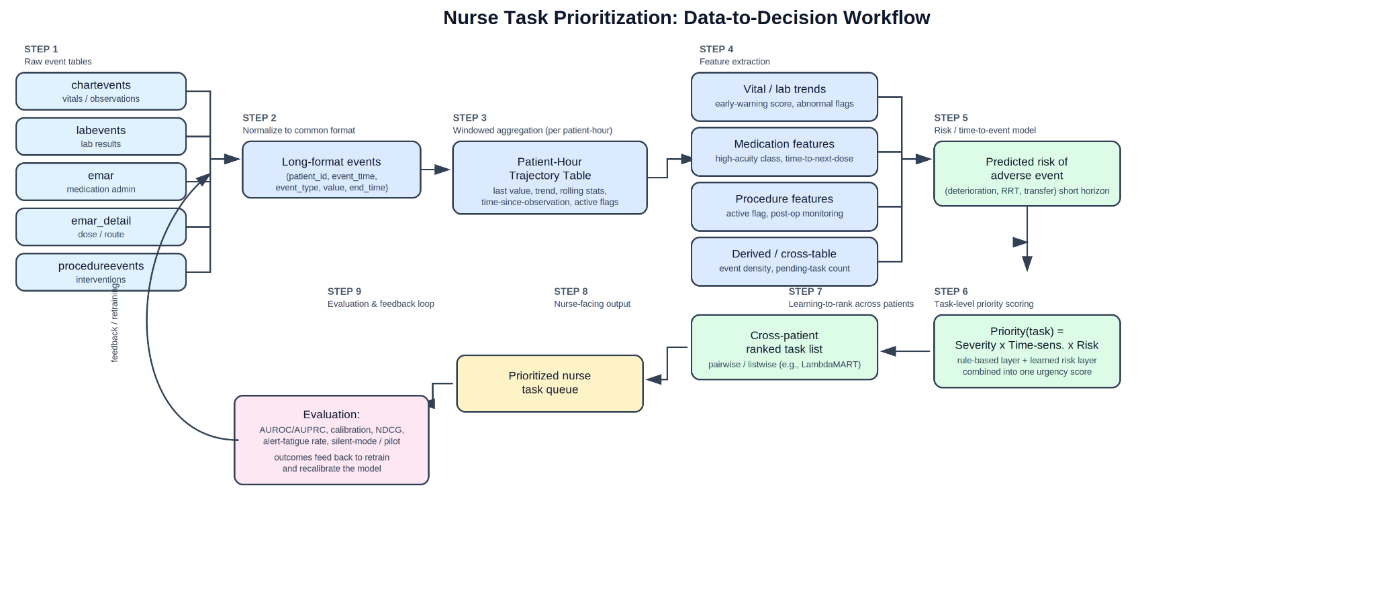1. Organizing and Combining Events Over Time

All five event tables (chartevents, labevents, emar, emar_detail, procedureevents) share the same three core fields: patient ID, timestamp, and what happened. This makes it possible to normalize them into one common long-format table: (patient_id, event_time, event_type, value, end_time).

From there, events are grouped into fixed time windows (e.g., hourly bins) to build a patient-hour trajectory table, one row per patient per hour, summarizing vitals, labs, medications, and procedures for that hour. Interval events like procedures or infusions are represented as "active/inactive" flags with elapsed duration rather than single timestamps, since they span a period rather than a moment. A parallel "time since last observed" column is kept for each feature, since measurement timing itself is informative.

This structure allows patients to be compared row by row, feeds cleanly into a model (which needs consistent structured input), and makes trends easy to spot over time.

2. Features Extracted From Each Table

chartevents: current vitals and deviation from normal range (e.g., HR > 120, MAP < 65); trend/slope over the last 30–60 minutes; composite early-warning scores (NEWS, SOFA); device-related signals (ventilator settings, new line placement).

labevents: abnormal-value flags and distance from normal range; rate of change (e.g., rising lactate, dropping hemoglobin); time since last result; derived organ-dysfunction indicators (e.g., AKI stage from creatinine).

emar / emar_detail: recent medication administrations and route; dose changes or titration of high-risk drugs (vasopressors, insulin); scheduled vs. PRN dosing, including overdue doses; presence of high-alert medications requiring monitoring.

procedureevents: recent or upcoming procedures and their post-procedure monitoring windows; procedure risk level; associated orders (e.g., frequent vitals after transfusion).

3. Assigning a Priority Score Across Multiple Patients

Tasks differ in type, so they can't be compared on raw values. The shared question across every task is: "If this isn't done right away, how bad could it get, and how soon?" This splits into two components: Severity (how dangerous if ignored) and Time Pressure (how soon it becomes a problem). These combine as:

Priority Score = Severity × Time Pressure

Patient | Task | Severity | Time Pressure | Priority Score
A | Insulin due in 5 | 6 | 9 | 54
B | HR rising fast | 8 | 8 | 64
C | Post-Exhubation monitoring | 7 | 6 | 42
D | High Lactate result | 9 | 7 | 63

Ranked order: B (64) → D (63) → A (54) → C (42)

Severity and time pressure can come from a rule-based checklist (simple, explainable, but rigid) or be learned from historical outcome data (more flexible, feeds into Question 4).

4. Machine Learning Approach, Target, and Evaluation

Approach: frame this as a risk-prediction model feeding into a ranking layer. Stage 1 trains a model (gradient-boosted trees, or a survival/time-to-event model) to estimate the probability of a significant decline within a short horizon (e.g., 1–4 hours). Stage 2 applies a learning-to-rank model (e.g., LambdaMART) to directly order tasks across all patients.

Alternative approach: a GRU/LSTM sequence model, specifically GRU-D, consumes the full patient trajectory directly rather than a single snapshot, learning temporal patterns without hand-engineered trend features. GRU-D is well-suited to irregular, frequently missing EHR data since it incorporates elapsed time since each variable was last observed directly into the network. This captures richer temporal dynamics but needs more labeled data and sacrifices some interpretability.

Prediction target (Y_t): a well-defined, objective adverse outcome (clinical deterioration, rapid response activation, or unplanned transfer) within a horizon h, not a reconstruction of historical nurse behavior, which would encode staffing bias rather than clinical urgency.

Evaluation compares predicted risk (Ŷ_t) against actual outcome (Y_t):

Predictive accuracy: AUROC, AUPRC (weighted heavily given rare events), calibration
Ranking quality: NDCG@k, checking whether the most urgent patients land at the top of the list
Clinical utility: false-alert rate, number needed to alert, and ideally a retrospective "silent mode" or pilot comparison before live deployment

5. Major Data Challenges and Mitigations

Irregular/informative sampling: measurement frequency reflects perceived severity, so encode time-since-observation as a feature rather than imputing naively.

Non-random missingness: a missing value often reflects a clinical decision, not randomness, so use masking plus time-decay (GRU-D) instead of mean-fill imputation.

Confounding by clinical response: clinicians already act on perceived risk, so the data reflects treated, not natural, trajectories; requires careful feature-time alignment and causal caution.

Label scarcity / class imbalance: no ground-truth urgency label exists and adverse events are rare, so use imbalance-aware metrics (AUPRC) and clinician-annotated validation samples.

Timestamp leakage: delayed documentation can leak future information, so enforce strict point-in-time feature construction.

Cross-source standardization: inconsistent naming/units across labs and medications require a standardization/mapping layer (e.g., to LOINC/RxNorm).

Generalizability: case mix, staffing, and EHR systems differ across sites, so validate externally and monitor for performance drift.

Privacy/governance: patient-level data requires de-identification, access control, and IRB oversight throughout.

